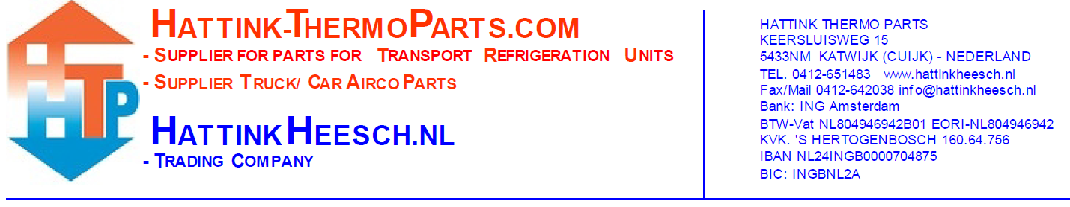
Request Return
Number | Articlenumber | Receiptnumber | Reason of return
Comments:

Your data:
Company name:
Contact:
Customer number:
In case of approval of the returned items by one of our employees, we charge the following costs:
A minimum of 15,- euro administration costs are charged. Additional costs are charged percentage wise as stated below:
10% cost (return within 7 days) of the net price from the order will be deducted, paid or credit note.
15% cost (return within 14 days) of the net price from the order will be deducted, paid or credit note.
25% cost (return after 14 days) of the net price from the order will be deducted, paid or credit note.
Articles which receive no consideration for exchange or restitution:
- Consumables such as refrigerant, sealant, and refrigerant oil
- Electrical components/parts such as circuit boards, thermostats, control panels, sensors, switches, and 12V/24V fans/blowers
- Items supplied under pressure or vacuum such as compressors
- Items that are used, damaged, or incomplete
- Specially ordered or custom-assembled items
Pay attention:
- No guarantee on seals and driers/filters for both original and imitation;
- The articles that you send back needs to be insured;
- It is important that the product is complete, unused and that it is in the original and undamaged packaging;
- Unstamped postal packeges will be not received;
- You pay the mailing costs and the payment costs of the webshop, these will not be refund or creditted;
- Without approval and return number from Hattink Thermo Parts no return.
You can find information about returns on our website among ‘Customer service’.
(www.hattink-thermoparts.com/customerservice)

